Early Learning Data Book Outline with Sources

Contents
Introduction (set the stage with focus on Kindergarten Assessment)
 | Purpose
Overview
- Include findings of this report
 | Approach
 | 0-6 Population in Linn, Benton, & Lincoln Counties (Goals & Indicators 2.3, 2.4) (high level i.e. county-level data)
 | Focus Population – define | Statute
 | Hub Roles and Indicators - define
 | Discuss urban/rural contrast in our region  % of children living in urban areas and % living in rural areas (by zip code) | American Fact Finder
 | Number of Children | American Fact Finder https://factfinder.census.gov/ faces/nav/jsf/pages/community  _facts. Xhtml
 | Race/Ethnicity | American Fact Finder
 | Low income (200% of federal poverty guidelines) (to be Preschool Promise ready if funds become available)  Consider Multi-Generational Poverty – if data is available | Census  Talk to people, go back 30 years
 | Poverty by Race/Ethnicity/County | American Fact Finder
 | Education Level by Race/Ethnicity/County | Adults, American Fact Finder

 | Finding children who are hidden (i.e. homeless) | See SRF data & other agencies & school districts
Kindergarten Readiness (a program focus of the EL Hub)
 | Demographics – 0-6 Population Related to Kindergarten Readiness Catchment Area (layering from county to school catchment areas and show trend data)
 | Kindergarten Assessment Scores – 3 years, by school attendance areas – top 10/bottom 10 | KA Data
 | 3rd Grade Reading Scores – 3 years, intact groups and full group – longitudinal data | Kristi will ask school districts & ODE
 | English Language Learners | KA Data
 | Gender | KA Data
 | Free & Reduced Lunches (include poverty level requirement) | KA Data
 | High School Graduation Rates by School District | ODE
 | Early Care and Education
 | Types of ECE Programs and Children Served  SPARK/Early Learning Supports -  #licensed/#slots by county,  # & range of star-rated programs (include any anomalies)/# of slots by county,  # recorded preschools/# of slots(include narrative regarding range of quality) | Jerri
 | Quality of ECE Programs (# of training hours/licensing - mention extracurricular courses like ERDC classes) | Jerri
 | Discuss the economic reality that child care providers face (low wages)
Stable and Attached Families (Goals & Indicators 3.2, 3.3, 3.4, county-level social determinants of health)
 | Maternal & Infant Health (regional & county- Level) | Community Health Assessment
 | Population of Potential Mothers | CHA

 | Prenatal Care  Timeliness of Prenatal Care | CHA
 | Teen Pregnancy | CHA
 | Substance Abuse Use During Pregnancy (include prescription drugs) | CHA
 | Births | CHA
 | Maternal and Infant health Indicators by Race/Ethnicity and County  Fertility Rate  % of Births for Which Mothers had Inadequate or No Prenatal Care  Maternal Smoking Rates Pregnancy Rate for Women Age 15-19 Years  Infant Mortality Rate Premature Birth Rate Low Birth Rate  Breast Feeding Rates Among WIC Mothers | CHA
 | Child Health | CHA
 | Health Insurance Coverage | CHA
 | CCO Measures | CCO
 | Developmental Screening - Birth to 3 years billable ASQ’s | CCO
 | Two-Year Old Immunization Rate | CCO
 | Obesity Rates | CCO
 | Oral Health | CCO
 | Adverse Childhood Experiences (ACES) – Include all items in statute for EL Hub, by county
 | Homeless, by county (how do we  define homeless families/children especially in urban vs rural areas?) | LBL ESD
 | Single Parents | American Fact Finder
 | Food Insecurity | 2017 County Data Book
 | Domestic Violence | DHS
 | Child Abuse & Neglect | DHS

 | Parent who is Currently Incarcerated or Within Past 3 Years | Kristi will ask OHA
 | Parent who Engages in Substance Abuse (Founded abuse) | OHA
 | Developmental Disability of Parent | OHA
 | Migrant Children under Age 6 | LBL ESD
 | Children under 6 in Foster Care  (include data on # of Foster Homes available) | DHS
 | Child and Family Support | DHS – TANF, WIC, SNAP, ERDC
 | Early Care and Education (reference information in KA section above)
 | Economic impact (i.e. employment, lay- offs) | Labor Market Economist
Summary and Interpretation
 | Key Themes
Priority Population – define and describe the population identified as a priority for the EL
Hub.
 | References
 | Glossary

AGENDA
DATA & EVALUATION WORKGROUP THURSDAY MAY 24, 2018
2:00 – 4:00 PM
Location: Mary’s Peak meeting room Sunset Building, Corvallis

- Welcome and Introductions
- PowerPoint: Analysis of 3rd Grade Reading Scores and KA Scores Association
- Data Book
  - Data: Revisit Introduction and Start Kindergarten Readiness
    - A Focus on Income inequality Report
    - Unmet Health Care Need Report
    - Next: Stable and Attached Families
  - Next steps
    - Design Concepts
    - Establish a timeline
- Next meeting: Find another date/time for Lincoln County meeting

Parking Lot:
- Revising “Our Region” section on the EL Hub Website
- Update Hot Spots
- LBL ESD Data Workgroup
- Immunization Data

Ensure that the EL Hub has the data it needs to make decisions informed by an understanding of the target population and progress towards outcomes.

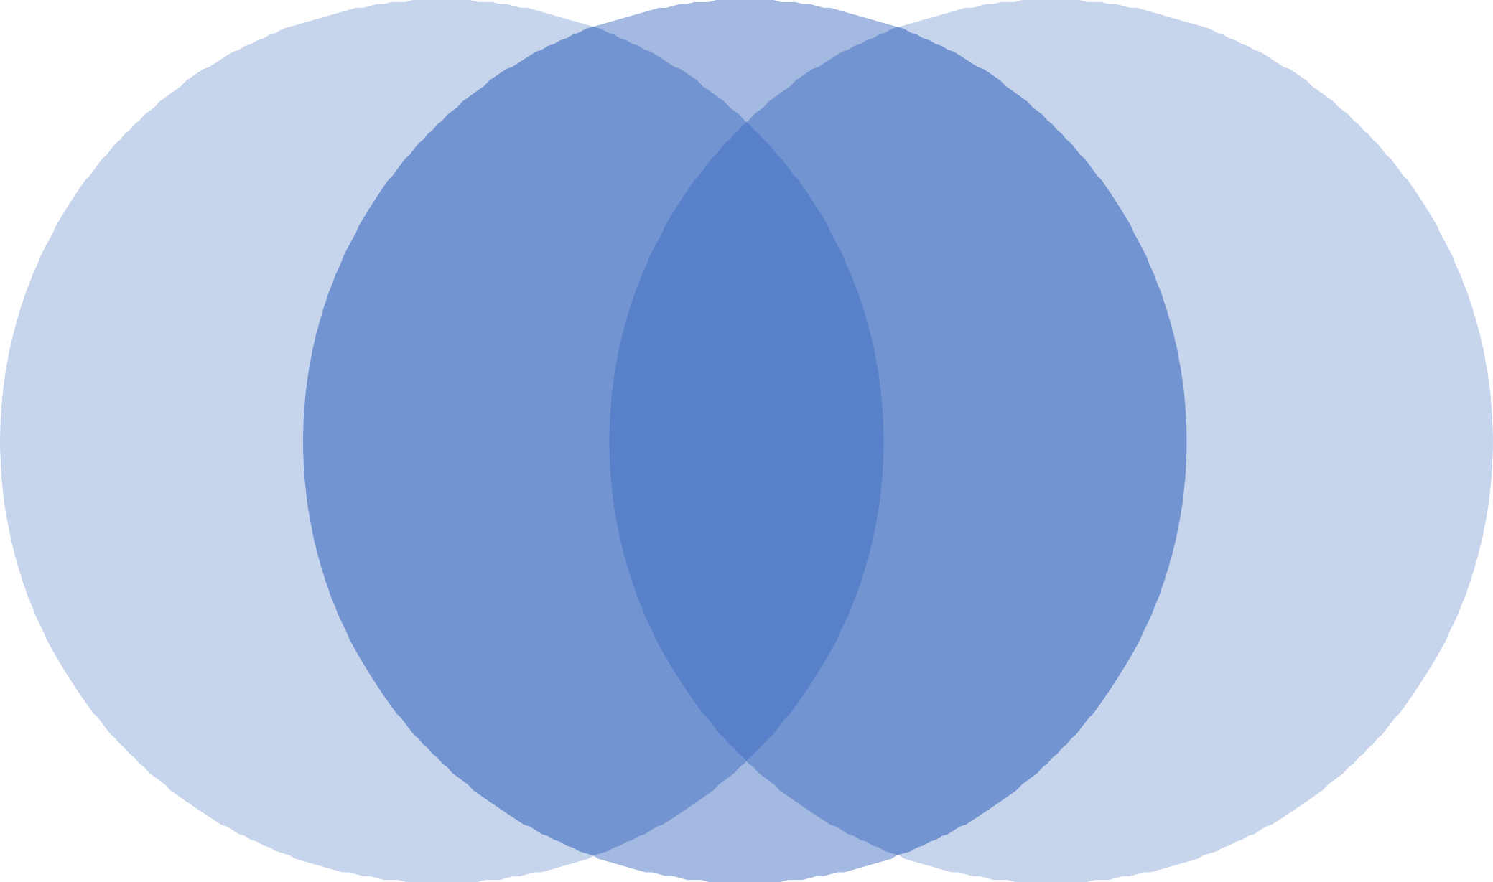

Analysis of 3rd grade reading scores and KA scores association

2016-2017

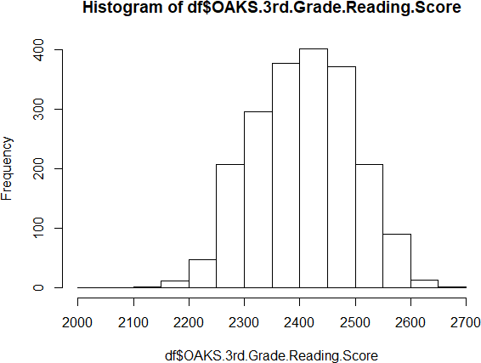
mean=2406.8

Histogram of df$Approaches.to.LearningT. otal.Score

0
I
0
Ii)

0
0
'SI"
>,
0
C 0
Q) 0
:::J <:'")
0-
Q)
LL 0
0
N

0
0

0

1 2 3 4 5

df$Approaches.to.Learning.Total.Score

Association

  - Increase in every point of approaches to learning total score increases 3rd grade reading score by 34.4 points.
  - And this is statistically significant.
  - In Benton county increase is 31.5 , statistically significant
  - In Linn county increase by 32.8 , statistically significant
  - In Lincoln county increase by 38.6 , statistically significant
  - Only in economically disadvantaged population:
  - it decreases 3rd grade reading score by 39.7 points.
  - ELL are significantly different from Not ELL (20.2 vs. 35.7)
  - Latino has 23.0 increase compare to total 34.4

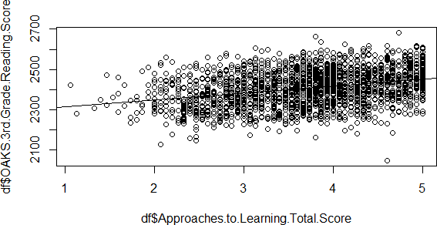

Analysis

  - To determine how approaches to learning affects 3rd grad reading scores, we will analyze two parameters:
1.) The average 3rd grade reading score: this describes whether one group generally scores better overall than another group on 3rd grade reading scores;
2.) The slope of the relationship between approaches to learning and 3rd grade reading scores: this describes how strong of an affect a higher approaches to learnings core has on a 3rd grade reading score.

By county:
Lincoln county average 3rd grade reading score is the lowest and affect of approaches to learning on 3rd grade reading score has the biggest gain.
Benton county average 3rd grade reading score is the highest and affect of approaches to learning on 3rd grade reading score has the smallest gain.

 | Benton | Lincoln | Linn | Total
Average 3rd grade reading score | 2,432.4 | 2,359.1 | 2,402.0 | 2,406.8
Affect of approaches to learning on 3rd grade reading scores | 31.5 | 38.6 | 32.8 | 34.4

Gender

  - Males and females are not significantly different in approaches to learning and 3rd grade reading scores relationship:
  - For boys: Increase of 33.84 for 3rd grade reading score for every point increase in approaches for learning score.
  - For girls: Increase of 33.77 for 3rd grade reading score for every point increase in approaches for learning score.

 | Boys | Girls
Affect of approaches to learning on 3rd grade reading scores | 33.84 | 33.77

English Language Learners

  - English Language Learners are significantly different from Not English Language Learners in approaches to learning and 3rd grade reading scores relationship:
  - ELL: Increase of 20.2 for 3rd grade reading score for every point increase in approaches for learning score.
  - Not ELL: Increase of 35.7 for 3rd grade reading score for every point increase in approaches for learning score.

 | ELL | Not ELL
Affect of approaches to learning on 3rd grade reading scores | 20.2 | 35.7

Economically Disadvantaged

  - Economically Disadvantaged kids are significantly different from Not Economically Disadvantaged in approaches to learning and 3rd grade reading scores relationship:
  - EcDis: Increase of 26.9 for 3rd grade reading score for every point increase in approaches for learning score.
  - Not EcDis: Increase of 37.0 for 3rd grade reading score for every point increase in approaches for learning score.

 | Economically Disadvantaged | Not Economically Disadvantaged
Affect of approaches to learning on 3rd grade reading scores | 26.9 | 37.0

