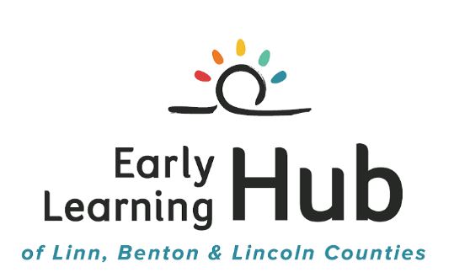
Agenda

Work Group Day

May 10, 2018

9:00 AM – 12:30 PM

9:00 – 9:15 | Welcome & Introductions
9:15 – 9:25 | Regional Equity Training Update
9:25 – 9:35 | ECCC Updates
9:35 – 9:45 | P-3 Alignment Updates
9:45 – 9:55 | Healthcare Integration Updates
9:55 – 10:10 | Data & Evaluation Updates
10:10 – 10:30 | Pollywog Project Update
10:30 – 11:00 | Hub Updates  - Current RFA  - Contracts & Funding  - ELC Strategic Planning
11:00 – 12:00 | Partner Sharing

