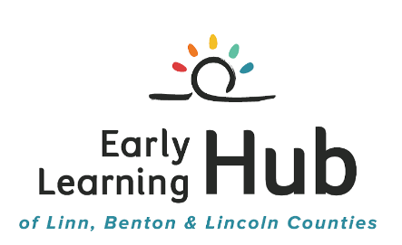

Summary of the NW Health Foundation HB+HC

Communities Collaborate Grant Application, Year One

The overall goal of the Communities Collaborate grant is to build power and improve outcomes during early childhood for children and their families most impacted by educational and health disparities. As a result of listening to our partners and parents our approach will be to increase the capacity of Hub partners to engage families, to identify potential parent leaders and then engage parents in leadership activities on boards and advisory groups. The EL Hub will continue to hold parent focus groups as a way to ensure the parent voice in Hub decision-making and we will provide incentives and address barriers to participation such as transportation and childcare.
Goal 1: Increase the capacity of culturally-specific EL Hub partner organizations to engage families
- Hire a Parent Engagement Coordinator
- Provide 8 monthly Parent Engagement and Capacity Building Trainings for culturally-specific partners in each county:
    - Simultaneous and translation services
    - Popular Education Methods
    - Peer support for partner agencies
    - Parent volunteer programs
    - Family engagement
    - Advocacy and civic participation
    - Leadership
    - Collaboration
Goal 2: Build relationships with parents/families who are participating with community-specific partners and who are interested in engaging as leaders, advocates and/or civic participants
- Conduct quarterly Parent Focus Groups for parent voice in EL Hub decision-making and to identify leaders
- Develop a Parent Leadership Development Training Plan to implement in Year 2
Goal 3: Increase the capacity of the EL Hub for unified change locally, in the tri-counties, and in the region
- Survey EL Hub partners for current parent advisory meetings and assess willingness to add agenda topics specific to EL Hub needs
- Increase the use of civic engagement and advocacy strategies for creating positive changes for children
Timeline:
- December 2015: NW Health Foundation announces awards
- January 2016: Year 1 of the Communities Collaborate grant period begins
- Summer 2016: Interim Report and Application for Year 2 of the Communities Collaborate grant
- January 2017: Year 2 of the Communities Collaborate grant starts

